2023

Data Analysis, Visualisation, and Interactive Dashboard: Unveiling Insights from DMart Tamil Nadu Grocery Sample Sales Data using Excel

**AJAY VIKRAM V**

BSC. DATA SCIENCE AND ANALYTICS 2ND YEAR – 3RD SEMESTER

16TH AUGUST 2023

# INTRODUCTION:

In the dynamic realm of contemporary business, data analysis serves as a powerful tool for informed decision-making and strategic planning. This project is a focused exploration of the DMart Tamil Nadu Grocery Sales Sample Data, a substantial dataset comprising details of **9994 orders** from **2021 Jan to 2023 Aug 10**. The dataset encompasses a wide array of variables including **order ID, customer names, product categories, quantities, regions, cities, dates, prices, payment modes, and profits**. Through meticulous data cleaning and Excel's capabilities, our goal is to uncover insights into profit trends, city-specific performance, payment method preferences, and the influence of product categories on profitability. This endeavour goes beyond conventional data representation, as we construct an interactive dashboard for dynamic exploration of insights. As we embark on this journey, our objective is to enhance data analysis skills, Excel proficiency, and impactful visualization techniques. Rooted in authenticity and a genuine pursuit of knowledge, we aim to contribute meaningful perspectives to retail management, enriching decision-making and strategic perspectives.

# AIM:

The primary aim of this project is to perform a comprehensive and insightful analysis of the DMart Tamil Nadu Grocery Sales Sample Data, which encompasses detailed information from 9994 individual orders. This analysis is driven by the aspiration to unravel multifaceted insights that can offer valuable perspectives on various dimensions of grocery sales within the context of DMart supermarkets.

1. Profit Trends: Analyse profit trends over time, **identifying patterns** and contributing factors to better understand the financial dynamics.
2. City Performance: Evaluate sales, profits, and customer **behaviour across different** cities in Tamil Nadu to gain insights into regional performance.
3. Payment Preferences: Explore payment method preferences (e.g., UPI, cash, card) to understand **common transaction** trends and implications.
4. Product Categories: Investigate how specific **product categories impact** overall

**profitability** by analysing sales quantities and profits.

1. Interactive Dashboard: Develop an engaging dashboard to **dynamically visualize insights**, enhancing user understanding and exploration.
2. Skill Enhancement: Improve data analysis and Excel proficiency through meticulous cleaning, analysis, and visualization.

In essence, the overarching aim of the project is to derive actionable insights from the DMart Tamil Nadu Grocery Sales Sample Data through rigorous analysis and visualization. By achieving these objectives, the project endeavours to offer meaningful contributions to the understanding of grocery sales dynamics within the DMart supermarket context.

# PROCEDURE:

1. Data Collection and Cleaning:
   * Collected the DMart Tamil Nadu Grocery Sales Sample Data containing information about 9994 orders.
   * Thoroughly examined the dataset for inconsistencies, missing values, and duplicates.
   * Cleaned the dataset by removing null values, duplicates, and ensuring consistent formatting.

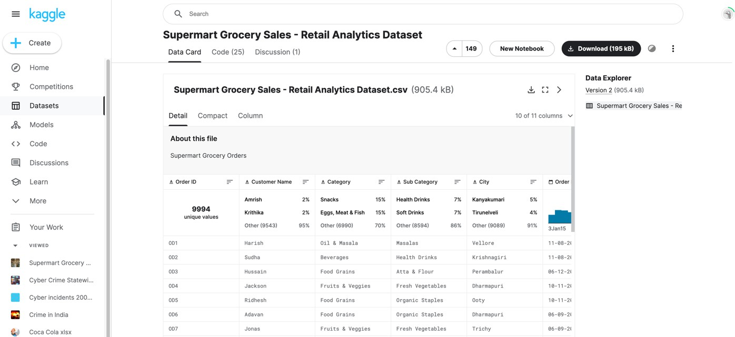

1. Data Exploration and Preparation:
   * Explored the dataset to understand the structure of variables and their relationships.
   * Converted relevant columns to appropriate data types (e.g., dates, numerical values).
   * Grouped data as needed to facilitate analysis (e.g., by year, city, payment method, product category).

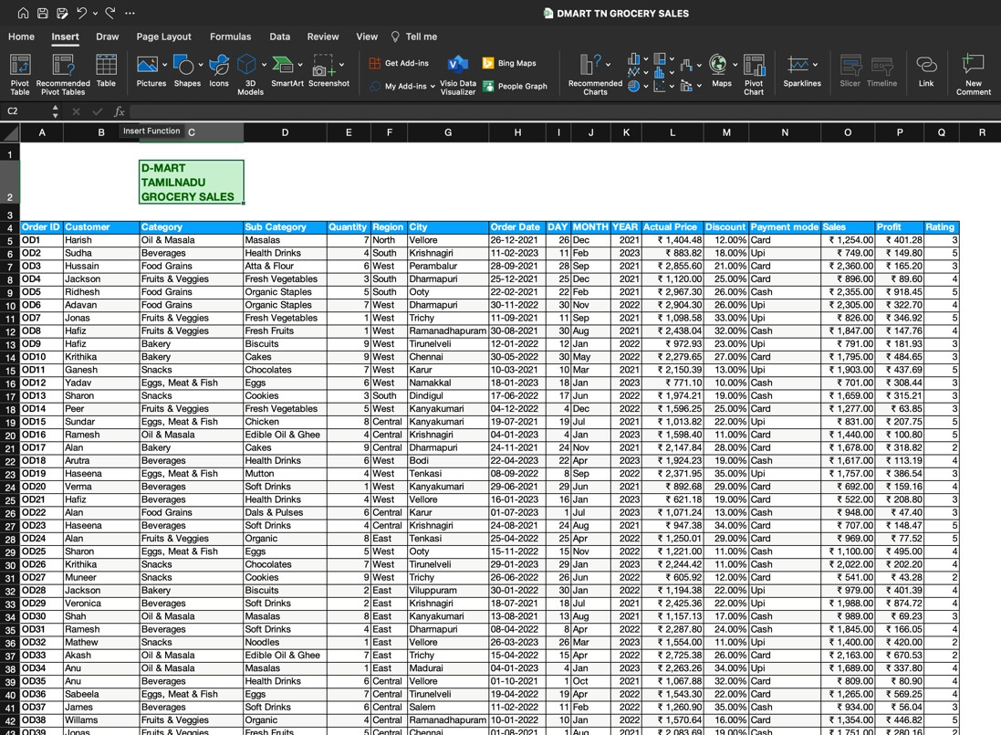

1. City Performance Evaluation:
   * Grouped data by city and calculated total sales and profits for each city.
   * Used Excel's pivot tables to summarize city-specific data:
     + Step 1: Click on any cell within the dataset.
     + Step 2: Go to the "Insert" tab, click "PivotTable," and choose the range of data you want to analyse. In the "Create PivotTable" dialog box, select the destination for the pivot table (e.g., a new worksheet), and click "OK."
   * Created clustered column bar graphs to compare city-wise sales and profits:
     + Step 1: Select the columns "City," "Total Sales," and "Total Profits" from the dataset.
     + Step 2: Go to the "Insert" tab, click "PivotChart," and choose "Clustered Column."
     + Step 3: Drag "City" to the Axis (Categories) field, "Total Sales" to the Values field, and "Total Profits" to the Values field. Format the chart as needed.
2. Payment Method Preferences:
   * Analysed payment modes (UPI, cash, card) by calculating the percentage of transactions for each mode.
   * Generated a doughnut graph to visually represent payment method preferences.
3. Product Category Impact:
   * Calculated profits for each product category by summing profits for related orders.
   * Organized data into pivot tables to summarize category-wise profits:
     + Step 1: Click on any cell within the dataset.
     + Step 2: Go to the "Insert" tab, click "PivotTable," and choose the range of data you want to analyse. In the "Create PivotTable" dialog box, select the destination for the pivot table (e.g., a new worksheet), and click "OK."
   * Created a clustered bar graph to display the impact of different product categories on overall profitability.
4. Profit Trend Analysis:
   * Calculated profit margins for each order using the formula: Profit = Sales Price - Actual Price.
   * Aggregated profits by year and month to understand profit trends over time.
   * Visualized profit trends using line graphs:
     + Step 1: Select the columns "Year," "Month," and "Profit" from the dataset.
     + Step 2: Go to the "Insert" tab, click "PivotChart," and choose "Line Chart."
     + Step 3: Drag "Year" to the Axis (Categories) field, "Month" to the Axis (Categories) field, and "Profit" to the Values field. Format the chart as needed.
5. Interactive Dashboard Creation:
   * Compiled the derived insights into an interactive dashboard using separate Excel worksheets.
   * Incorporated slicers to enable dynamic filtering and exploration by users:
     + Step 1: Select a cell within the pivot table or pivot chart.
     + Step 2: Go to the "Insert" tab, click "Slicer," and choose the fields you want to use as filters. Arrange the slicers on the dashboard and connect them to the pivot tables and charts using "Report Connections."
   * Organized and formatted the dashboard elements for a visually appealing and user- friendly experience.

# RESULT AND OUTPUT:

The thorough analysis of the DMart Tamil Nadu Grocery Sales Sample Data has generated significant insights, showcasing valuable outcomes in various dimensions:

1. Profitable City Identification:
   * **Vellore** emerges as the highest profit-making city, providing a focal point for strategic resource allocation and expansion efforts.

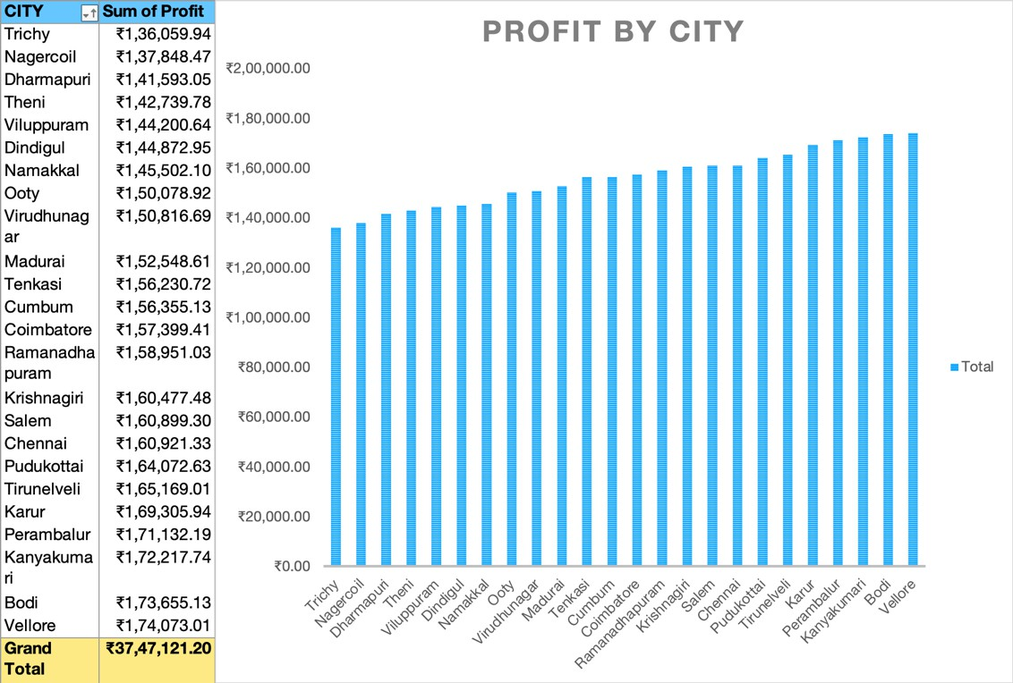

1. Preferred Payment Method Insights:
   * **UPI** stands out as the most commonly used payment mode and **Cash** mode payment has gained more profit, offering actionable information to enhance payment processes and user experience.

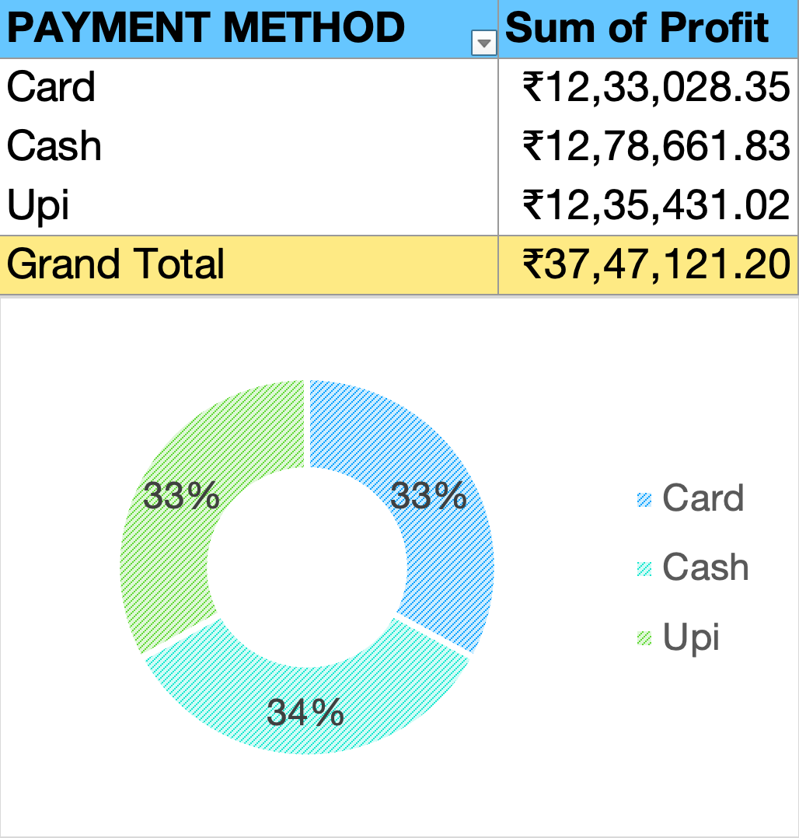

1. Lucrative Product Category Recognition:
   * 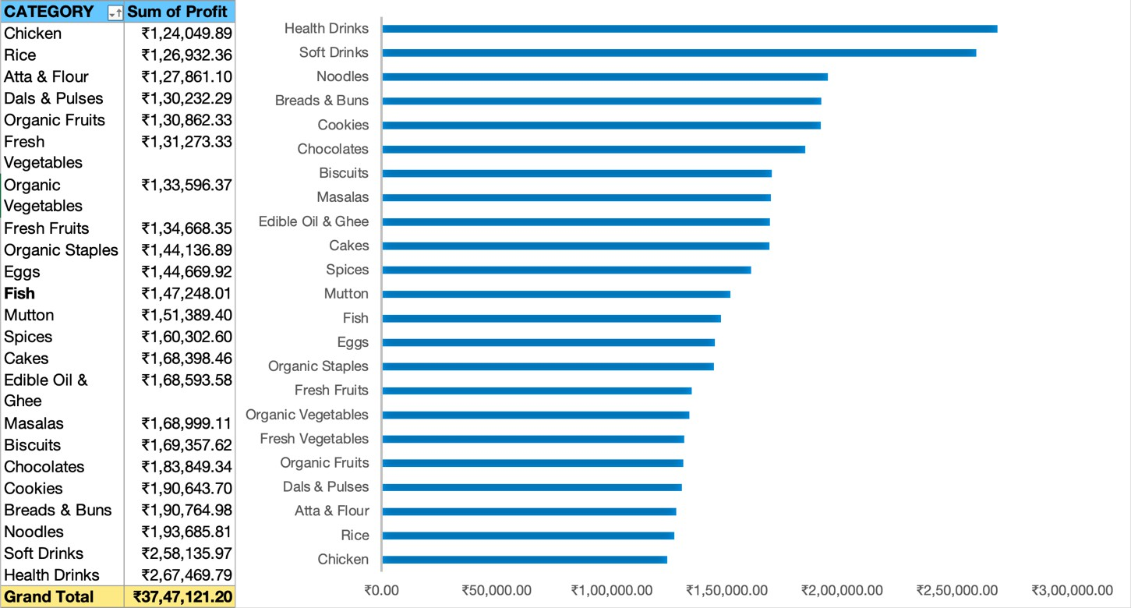The profitability analysis pinpoints **health drinks** as the most lucrative category, guiding inventory management and targeted marketing strategies.
2. Visualized Profit Trends:
   * The visual representation of **profit trends** elucidates growth patterns and fluctuations, aiding in recognizing profitable periods.

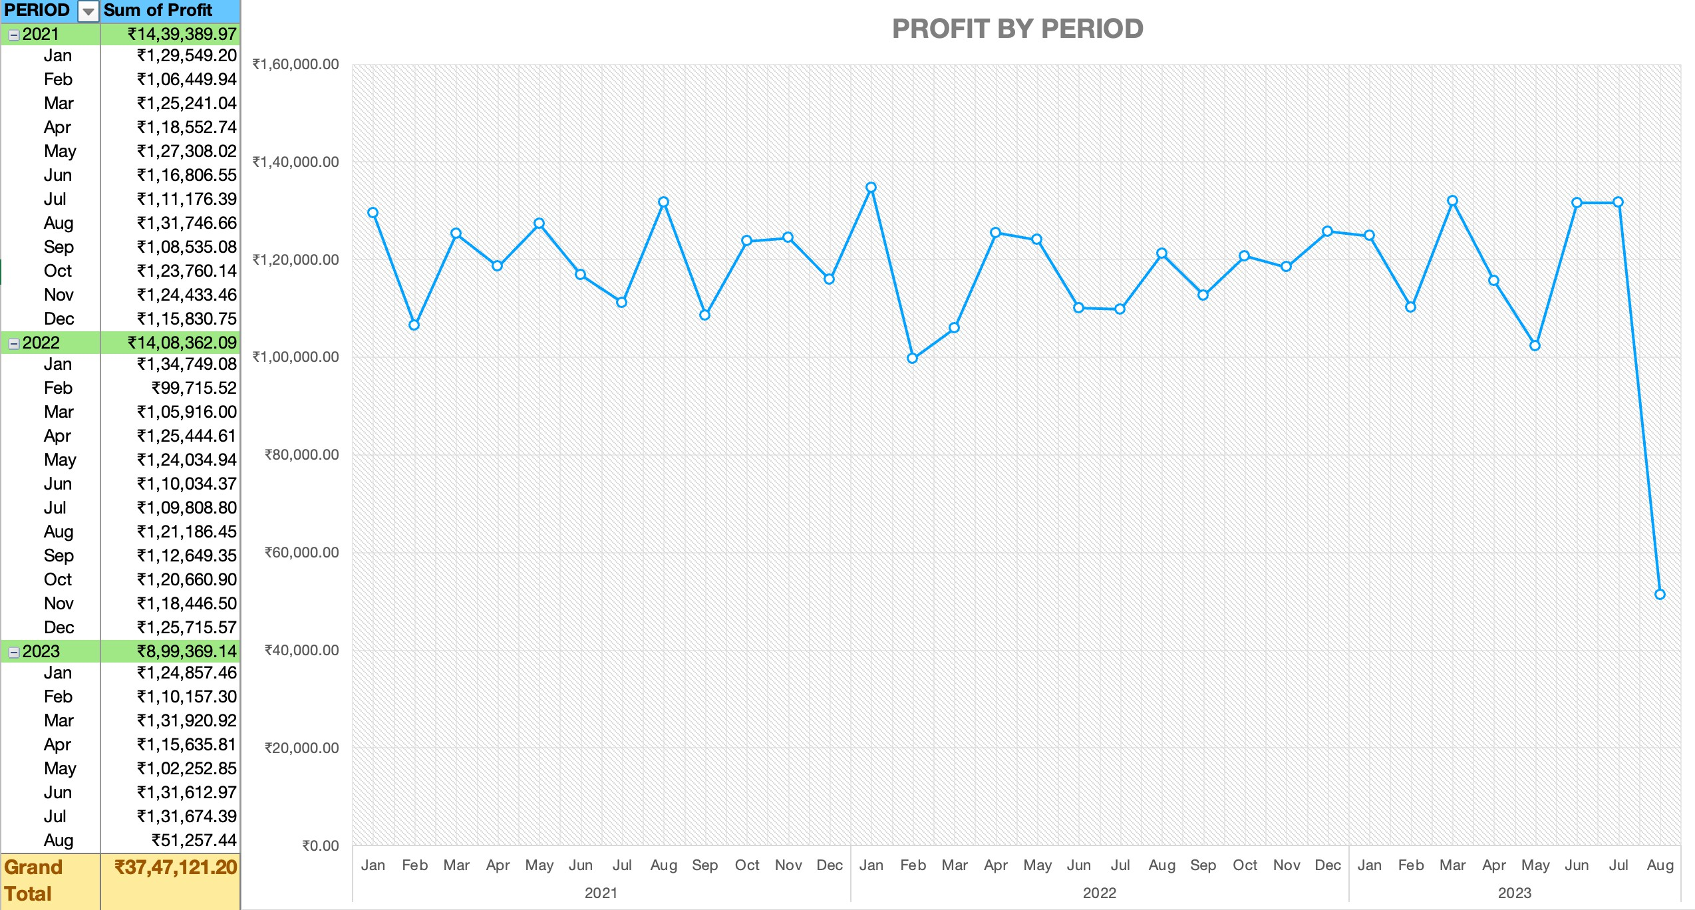

1. Interactive Dashboard Empowerment:
   * The interactive dashboard amplifies data exploration through **dynamic filters**, facilitating detailed insights and informed decision-making.

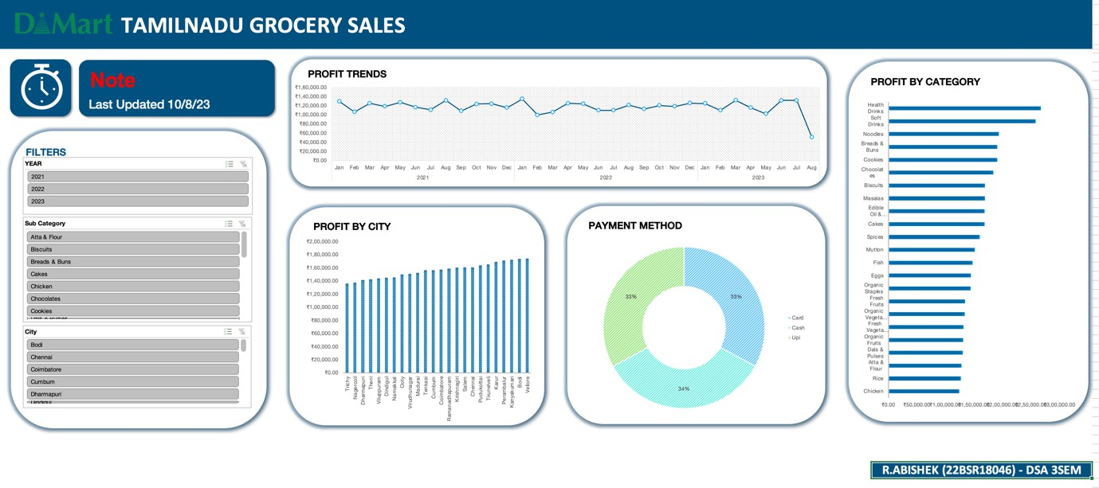

This section concisely conveys the key findings of the data analysis process, highlighting significant insights and the **interactive dashboard's** ability to enhance data exploration and interpretation.

# CONCLUSION:

Through meticulous analysis and visual representation of the DMart Tamil Nadu Grocery Sales Sample Data, this project has unveiled valuable insights into profitable cities, payment preferences, and product categories. The interactive dashboard's dynamic filters empower data exploration, enhancing decision-making capabilities. These findings equip us with actionable intelligence to optimize strategies, refine operations, and drive growth in the retail domain.

# REFERENCE:

https://[www.kaggle.com/datasets/mohamedharris/supermart-grocery-sales-retail-analytics-](http://www.kaggle.com/datasets/mohamedharris/supermart-grocery-sales-retail-analytics-) dataset